Final Year Project Report

Luke Taylor

Final Year Project Report  
  
Luke Taylor  
  
  
  
  
  
Supervisor:   
  
Stavros Didakis  
  
  
  
  
  
BSc Internet Design  
  
Plymouth University

February 2018

Word Count: 1332

Table of Contents

List of Figures 4

Chapter 1 – Introduction 5

Chapter 2 – Background 6

Chapter 3 – Methodology 7

Chapter 4 – System Development / Data Analysis 8

Chapter 5 – Discussion / Conclusion 9

References 10

Appendices 11

# List of Figures

Figure 1(Hivehome.com, n.d.) Nest Smart Thermostat 5

Figure 2(Britishgas.co.uk, n.d.) British Gas Smart Meter 5

Figure 4(Archdata.org, n.d.) ARI Exterior 7

Figure 3(Archdata.org, n.d.) ARI Interior 7

Figure 6(Obscura Digital, n.d.) Unseen Stars 8

Figure 5(Obscura Digital, n.d.) UAE National Day 8

# Chapter 1 – Introduction

(250 Words)

Introduction (general overview of this project, hypothesis or questions that were created at the beginning of the project – Why is this work important? What are you trying to achieve? Aims and objectives).

For my final year project i would like to create a project based around the topics of Internet of things, Live art installation, open data and environmental sensing. These are topics I have been most interested in throughout my degree, and would like to explore them further in my final year project. I would also like to encorparate a solid mixture of software and physical development in my build to further progress and test skills I have gained on other previous modules.

My aim is to build a smart interactive artpiece that can visualise the consumption of resources in the home environment, for example electricity, water, gas, data, consumables and money. This idea could then be taken and placed within the home to act as an interesting and more user friendly, living “smart meter”. The standard smart meter such as the nest or hive are becoming more commonplace however they are expensive, require professional installation and they all rely to heavily on precision numbers and graphs, this means the results are more beneficial to the companies that supply them and the professinals who can read them. The average consumer will require time and effort to decipher the meter, and leave them uninterested in the results thus rendering their purpose obsolete. My idea will solve this by giving the home an interesting, more obvious and easier to read representation of the amount of resources the home is consuming for the occupant. This will help the home occupant to save money, lower their carbon footprint and help the struggling environment.

# Chapter 2 – Background

(1000 Words)

Background (all related references that have inspired this work, or any philosophical, theoretical, or practical context that this development is based on.).

Within the internet of things and smart home technology sector, smart meters are becoming more popular. With the likes of the Nest or hive which are smart thermostats or electrical smart meters supplied by companies such as edf energy or british gas, some examples of these can be seen below.

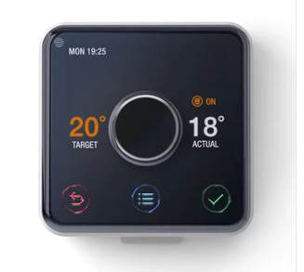

Figure 1(Hivehome.com, n.d.) Nest Smart Thermostat

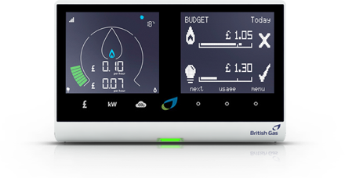

Figure 2(Britishgas.co.uk, n.d.) British Gas Smart Meter

I feel that these smart meters are a great step in the direction of better resource management and that the data produced is both helpful to the company and the consumer to help save money and better the environment, however I think they could be better. I feel that there are a number of problems with smart meters as they are right now, these problems being that; they can be expensive, they have to be installed by a professional, they usually only cover one or two resources, they can be boring to look at and rely heavily on numbers and graphs making them hard to decipher.

This project stems from a number of inspirations, The main one being the psychotropic house. One thousand Dreams of Stellavista by J. G. Ballard is an interesting short story set around psychotropic houses. A psychotropic house is a building designed to sense and mirror the psychologic state of their occupants and change aspects such as shape and layout accordingly, some homes have complete control of all aspects, “It's always interesting to watch a psychotropic house try to adjust itself to strangers, particularly those at all guarded or suspicious. The responses vary, a blend of past reactions to negative emotions, the hostility of the previous tenants” (Ballard, 1992). I found this interestring because houses are usually shaped to their owners and are often a reflection of themselves for example, decoration, furnishings or layouts and modifications, most of which have to be left behind when the owner moves, leaving an impression of the last tennant on the new tennant. I feel this is even more relevent with todays technology as a lot of homes have other smart control systems for lighting, security, heating etc. Later on in the story the main character is asked to move into a normal static home and responds with “it's not just dull, it’s dead.” (Ballard, 1992). This was also interesting to me as the house is seen as its own living and concious entity. I wanted to encorporate this into my own project and create a piece for the home that feels alive and aware.

Another inspiration for my project is the Umwelt. The umwelt is a concept introduced by german biologist Jakob von Uexküll in 1909. The word umwelt in german means ‘environment’ and is used to express the simple fact that different environmental signals are received by different animals even within the same ecosystem and that what they can sense is the limit of their entire objective reality. The phrase is often translated as ‘self-centered world’ this also comes across in one for Jakob Von Uexküll’s books where he describes it as “a soap bubble around each creature to represent its own world, filled with the perceptions which it alone knows.” (Schiller, Kuenen and Uexküll, 1957). I found this topic interesting when putting it into perspective with the internet of things and smart home technology. I was also interest in the works of a neuroscientist from stanford university called David M. Eagleman whos work is based around the umwelt which he presents on a ted talk, as what he calls “sensory substitution”, “sesnory extensions” and “sensory peripherials” (Eagleman, 2015). During the talk he shows a vest and app that he created to pick up sound and transfer that to vibrations which are fealt in the wearers back in order to help deaf people restore hearing using a new sensory output. He then goes on to explain how this could be used to create new senses for humans that may be used in the future, his example was stock market exchanges, or drone pilots. This was really inspiring for my project to try and create a new sense or feeling to extend the human umwelt.

From my research into the field of the internet of things and current smart home technology, I found a project called synthetic sensors by Geirad Laput. This project is aiming to create a new type of sensor that can work across a broad range of appliances and visualise it, on the project website it is described as “a single, highly capable sensor can indirectly monitor a large context, without direct instrumentation of objects. Further, through what we call Synthetic Sensors, we can virtualize raw sensor data into actionable feeds” (Laput, 2018). I found the broad range of this sensor really interesting as it can capture the use of many appliances throughout its environment such as taps, lights, washer, dryer or any other appliance throughtout the home or workspace such as computers, power tools etc all from one sensor. I began to think about the useful data that this would produce and how it could be better used within a IOT based project. I wanted to incorporate this sensor into my work but unfortunatley its not on sale yet and is only a prototype.

I also took some time in the early stages of my project to look at architectural facades and their use in creating art which had some influence on my project visualisation. Some projects I would like to highlight which influenced the project. The first is the arab world institute in paris designed by Jean Nouvel, where the complete glass side of the building is covered in an always changing metal façade that opens and closes like a camera apperature to controll interior light and tempurature levels.

Figure 4(Archdata.org, n.d.) ARI Exterior

Figure 3(Archdata.org, n.d.) ARI Interior

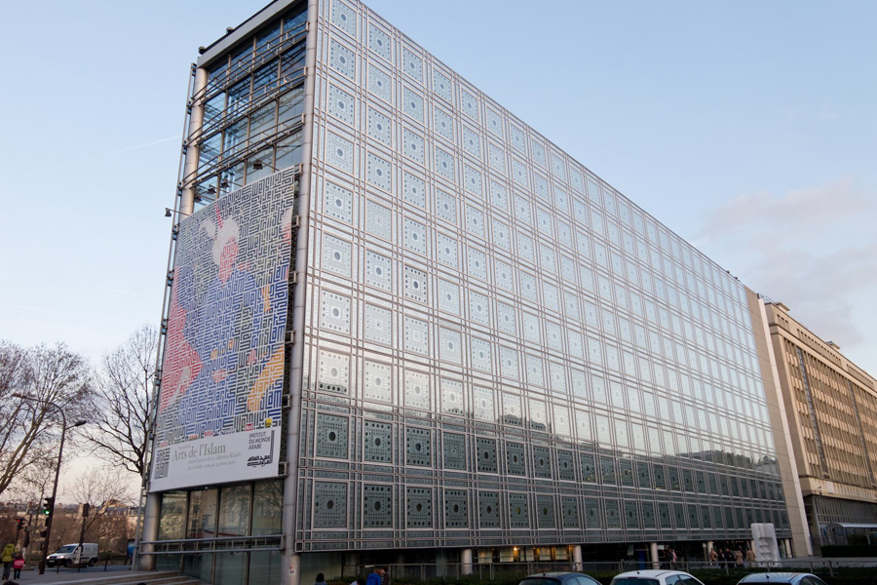

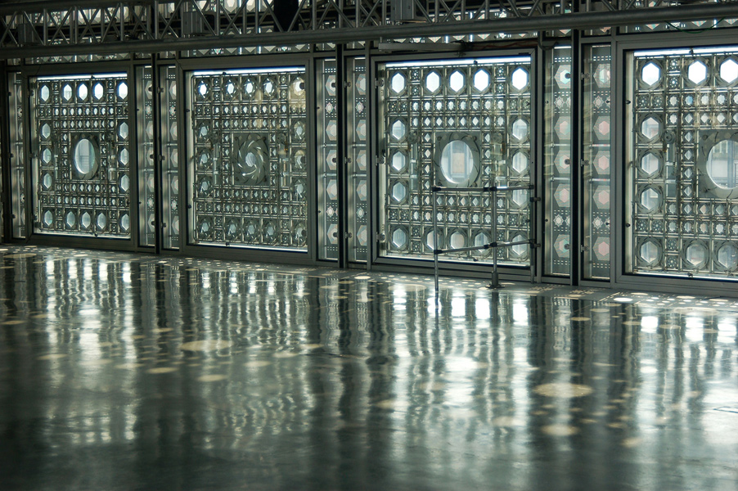

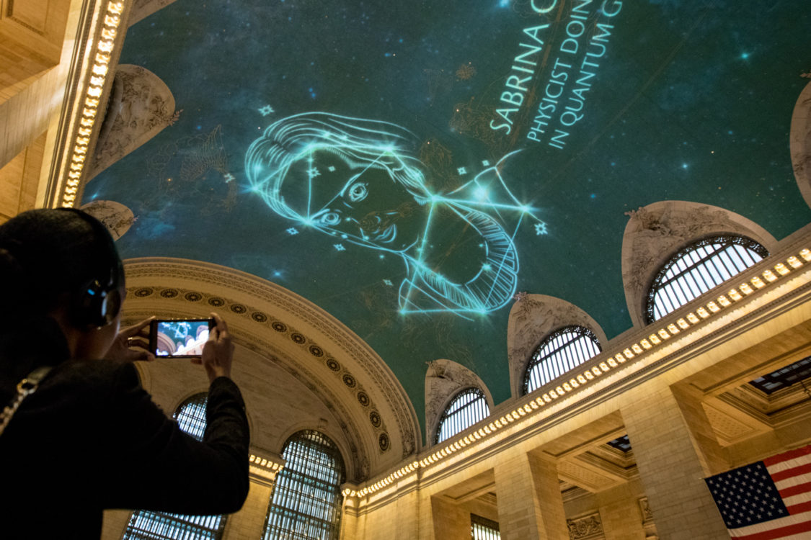The other art I would like to highlight is Architectural projection, where digital images are painted onto the side of buildings with the use of multiple projectors, this can be seen to have a brilliant effect and put art on a new level of consumption with such large canvases. Some particular projects that stood out were the UAE national day celebration where a company called OBSCURA Digital projected imagery on the sheikh zayed grand mosque in abu dhabi and their Unseen Stars projection in the grand central station terminal in new york.

Figure 6(Obscura Digital, n.d.) Unseen Stars

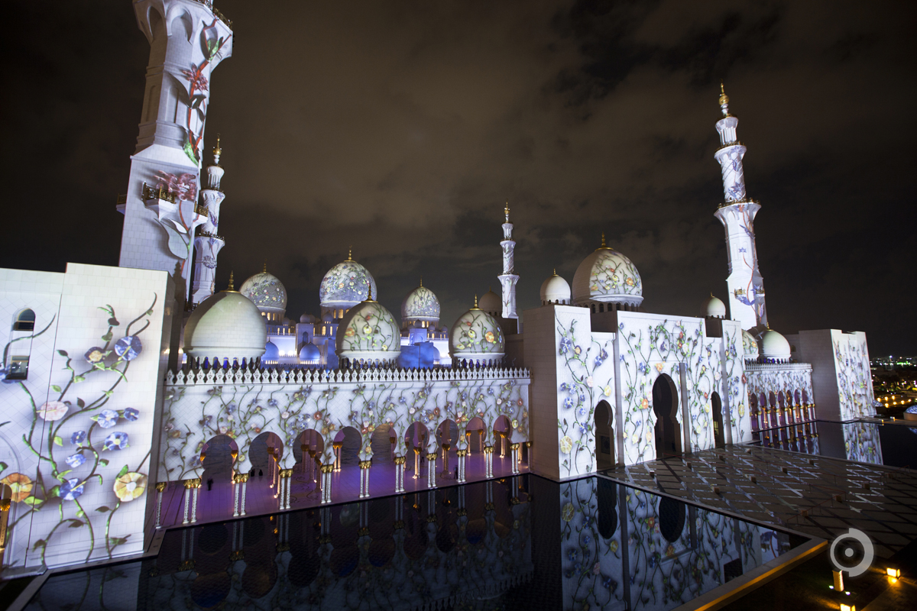

Figure 5(Obscura Digital, n.d.) UAE National Day

Other projects (artist makes a mirror out of eanything, happy life, co2 censor facade)

# Chapter 3 – Methodology

(750 Words)

Methodology (the development practice and structure that was followed to make this project. Any specific techniques or technologies used should be mentioned here).

Resources model

# Chapter 4 – System Development / Data Analysis

(2250 Words)

# Chapter 5 – Discussion / Conclusion

(750 Words)

Analysis / Discussion of Results (provide a critical analysis of your work, so as to explain what works and what doesn’t, what needs to be adjusted or needs to be done in a future update. Conclusion (Recap all previous content, summarize, explain what is the main outcome of this work, and close the report).

# References

1. Hivehome.com. (n.d.). Hive Active Heating. [online] Available at: https://www.hivehome.com/products/hive-active-heating [Accessed 17 Mar. 2018].
2. Britishgas.co.uk. (n.d.). Energy saving tips. [online] Available at: https://www.britishgas.co.uk/energy-saving/energy-saving-tips.html [Accessed 17 Mar. 2018].
3. Ballard, J. (1992). Vermilion sands. London: Phoenix.
4. Schiller, C., Kuenen, D. and Uexküll, J. (1957). Instinctive Behavior; The Development of a Modern Concept. Introd. by Karl S. Lashley. Contributors. New York: International Universities Press.
5. Eagleman, D. (2015). Can we create new senses for humans?. [Blog] TED. Available at: https://www.ted.com/talks/david_eagleman_can_we_create_new_senses_for_humans [Accessed 13 Mar. 2018].
6. Laput, G. (2018). Gierad Laput | Synthetic Sensors. [online] Gierad.com. Available at: http://www.gierad.com/projects/supersensor/ [Accessed 16 Mar. 2018].
7. Archdata.org. (n.d.). Archdata | Arab World Institute. [online] Available at: http://www.archdata.org/buildings/12/arab-world-institute [Accessed 16 Mar. 2018].
8. Obscura Digital. (n.d.). UAE National Day Celebration Projections - Obscura Digital. [online] Available at: http://obscuradigital.com/work/uae-national-day-celebration/ [Accessed 16 Mar. 2018].
9. Obscura Digital. (n.d.). "Unseen Stars" at Grand Central Terminal - Obscura Digital. [online] Available at: http://obscuradigital.com/work/unseen-stars-grand-central-terminal/ [Accessed 16 Mar. 2018].

# 

# Appendices